Public APIs List

🌐 What Is a Public APIs List?
# Source: Chatgpt (GPT-5-Mini) at [1/19/2026]
A Public APIs List is a collection of freely accessible APIs (usually without strict access restrictions or paid subscriptions) that developers can use for learning, building apps, testing, or prototyping.
These APIs are publicly available on the internet, often with:
- ✅ No login required (or free API key)
- 📖 Open documentation
- 🔄 Stable endpoints
- 💡 Useful sample data or services (weather, news, books, etc.)

🧩 Categories of Public APIs
# Source: Chatgpt (GPT-5-Mini) at [1/19/2026]
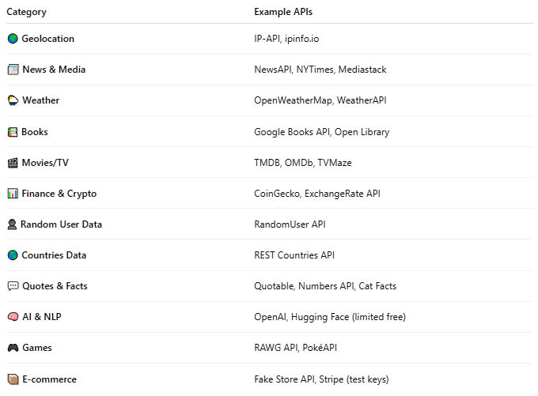
Category | Example APIs
🌍 Geolocation | IP-API, ipinfo.io
📰 News & Media | NewsAPI, NYTimes, Mediastack
🌦️ Weather | OpenWeatherMap, WeatherAPI
📚 Books | Google Books API, Open Library
🎬 Movies/TV | TMDB, OMDb, TVMaze
📊 Finance & Crypto | CoinGecko, ExchangeRate API
👤 Random User Data | RandomUser API
🌎 Countries Data | REST Countries API
💬 Quotes & Facts | Quotable, Numbers API, Cat Facts
🧠 AI & NLP | OpenAI, Hugging Face (limited free)
🎮 Games | RAWG API, PokéAPI
📦 E-commerce | Fake Store API, Stripe (test keys)

🗂️ Examples of Curated Public API Lists
# Source: Chatgpt (GPT-5-Mini) at [1/19/2026]
Here are trusted sites that maintain public API directories:

1. 🧰 public-apis.io
# Source: Chatgpt (GPT-5-Mini) at [1/19/2026]
- Clean, categorized API list
- With links, auth info, and use cases

2. 📚 GitHub: public-apis
# Source: Chatgpt (GPT-5-Mini) at [1/19/2026]
- Huge open-source list on GitHub
- Sorted by category
- Updated by the developer community

3. 🔎 RapidAPI Hub
# Source: Chatgpt (GPT-5-Mini) at [1/19/2026]
- Public APIs for every domain
- Free & paid plans
- Built-in testing console

4. 🧪 API Ninjas
# Source: Chatgpt (GPT-5-Mini) at [1/19/2026]
- Free APIs for facts, quotes, recipes, IPs
- Quick JSON responses
- No sign-up required

✅ Features of Public APIs
# Source: Chatgpt (GPT-5-Mini) at [1/19/2026]
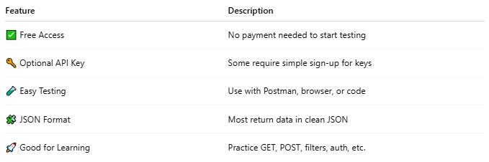

Feature | Description
✅ Free Access | No payment needed to start testing
🔑 Optional API Key | Some require simple sign-up for keys
🧪 Easy Testing | Use with Postman, browser, or code
🧩 JSON Format | Most return data in clean JSON
🚀 Good for Learning | Practice GET, POST, filters, auth, etc.

🧪 Examples You Can Test Right Now
# Source: Chatgpt (GPT-5-Mini) at [1/19/2026]
- Random User:
https://randomuser.me/api/
- REST Countries:
https://restcountries.com/v3.1/all
- Cat Facts:
https://catfact.ninja/fact
- CoinGecko (crypto prices):
https://api.coingecko.com/api/v3/simple/price?ids=bitcoin&vs_currencies=usd
- Joke API:
https://v2.jokeapi.dev/joke/Programming

📚 How to Access a Public APIs List and Discover APIs by Category
# Source: Chatgpt (GPT-5-Mini) at [1/19/2026]
There are several websites and tools that provide access to thousands of free public APIs, all neatly organized by category, auth requirements, and use cases. Here's how to do it:

✅ 1. GitHub: Public APIs Repository
# Source: Chatgpt (GPT-5-Mini) at [1/19/2026]
🔗 URL: https://github.com/public-apis/public-apis
🔎 How to Use:
- Open the link.
- Browse by category (e.g., Anime, Animals, Books, Business, Health, Weather, etc.).
- Each entry includes:
  - API name
  - Description
  - Auth type (None, API key, OAuth)
  - HTTPS support
  - Link to the official API
📌 No signup needed — 100% open-source.

✅ 2. Public APIs Directory: https://public-apis.io
# Source: Chatgpt (GPT-5-Mini) at [1/19/2026]
🔎 Features:
- Beautiful UI
- Categorized by domain: Entertainment, Crypto, Sports, etc.
- Tags like "No Auth", "Free", "JSON", etc.
- Direct links to API docs and base URLs
✅ Great for visual browsing.

✅ 3. RapidAPI Hub: https://rapidapi.com/hub
# Source: Chatgpt (GPT-5-Mini) at [1/19/2026]

🔎 Features:
- Discover APIs by Category, Collection, or Function
- Built-in API testing panel (no need for Postman)
- Shows request examples, code snippets (Python, JS, etc.)
🆓 Has free tiers for many APIs, and optional paid plans.

✅ 4. API Ninjas: https://apininjas.com
# Source: Chatgpt (GPT-5-Mini) at [1/19/2026]
🔎 Features:
- Simple, ready-to-use APIs with minimal setup
- Examples: Quotes, Jokes, IP lookup, Recipes, Timezone
- Great for beginners

✅ 5. ProgrammableWeb (legacy archive)
# Source: Chatgpt (GPT-5-Mini) at [1/19/2026]
🔗 https://www.programmableweb.com/category/all/apis
📦 One of the oldest databases (no longer actively maintained, but still useful).

🔍 Discover APIs by Category – Examples
# Source: Chatgpt (GPT-5-Mini) at [1/19/2026]
Category | Examples (Free APIs)
🌦️ Weather | OpenWeatherMap, WeatherAPI, Weatherbit
🌍 Location | REST Countries, IPinfo, GeoJS
📰 News | NewsAPI, NY Times API, Mediastack
🎬 Movies | TMDB (The Movie DB), OMDb API, TVMaze
💬 Communication | Twilio, SendGrid, Mailgun (limited free tiers)
🎵 Music | Spotify API, iTunes API, Last.fm
🧪 Testing Data | Random User, JSONPlaceholder, Mockaroo
🐱 Fun | Cat Facts, Dog CEO, Joke API, Chuck Norris Jokes

🛠 How to Start Using a Public API
# Source: Chatgpt (GPT-5-Mini) at [1/19/2026]
- Choose an API from one of the above sites.
- Open its documentation link.
- If it requires an API key, sign up for free.
- Test it using:
  - Postman
  - Browser (for GET)
  - Code (PHP, JS, Python, etc.)

